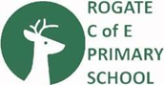

SCHOOL MILK – Every child under the age of 5 is entitled to FREE school milk.
Please register your child and milk will be automatically delivered to school. Once they reach the age of 5, you are then able to purchase milk via the same website at a subsidised cost - https://www.coolmilk.com/register-pupils

