Sons, Schisms and Six Wives – Buzzard Class (Year 5 and 6)
Summer Term 2022
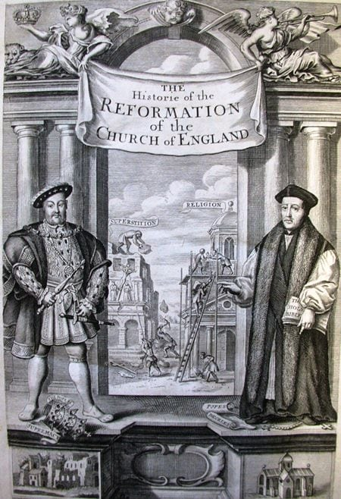  Sons, Schisms and Six Wives is primarily a history topic | Literacy, communication and language  Key text – Treason by Berlie Doherty  Sonnets  Instructional text  Autobiographical (diary)  Narrative  French: Time travelers and what’s the time? | Mathematics  Perimeter and area  Volume  Statistics  Measures  Property of shape  Problem solving | Physical Development  The Daily Mile  Athletics  Catching and fielding  Net and racket
 | Understanding the world  Science: STEM activities and evolution and inheritance  Computing: Databases and block coding  Geography: The Amazing Americas  History: The Reformation | Expressive art and design  Design Technology: Tudor purses  Art and design: Hans Holbein and portraits  Music: Musical textures and Leavers Service songs | Personal, social and emotional development  Relationship and sex education  Transition  Identity  Economic wellbeing  Trip to St Michael’s, Up Marden  Trip to Petworth House

